**EQUIPMENT REQUEST FORM**

**User’s Manual**

1. **Go to** [**http://10.27.1.170:9292/default.aspx**](http://10.27.1.170:9292/default.aspx) **and login your account.**

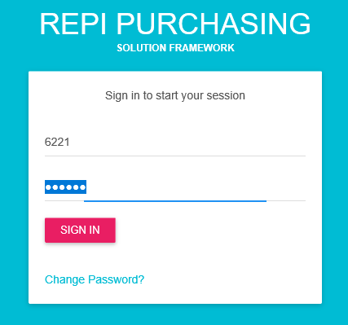

1. **Navigate EQUIPMENT REQUEST FOR OPERATION to see all options assigned to your account.**

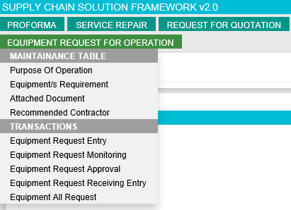

1. **If you want to create new request then go to EQUIPMENT REQUEST FOR OPERATION > Transactions > PullOut Request Entry**

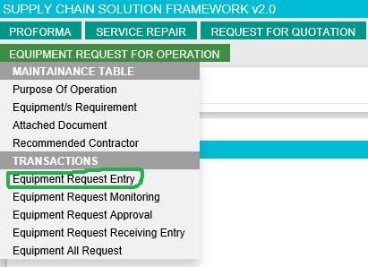

* **3.1 Enter all required field before clicking SUBMIT button. If you missed to fill up required fields then the system will inform you. See example below;**

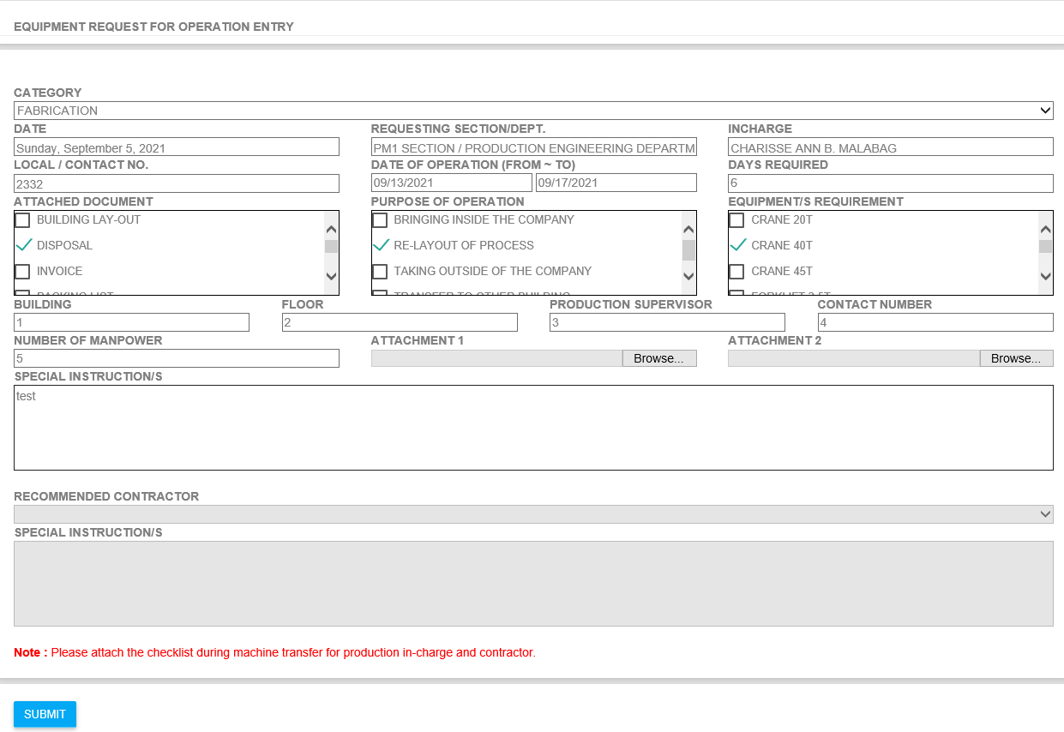

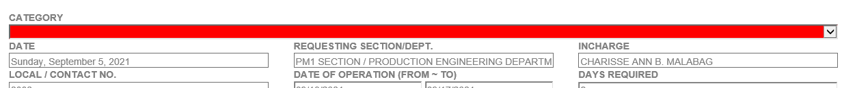

* **3.2 You will be redirected to success page if there is no error after clicking SUBMIT Button**

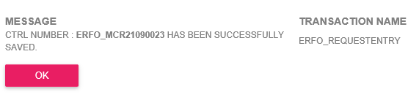

1. **If you want to check or monitor your request the go to EQUIPMENT REQUEST FOR OPERATION > Transactions > Equipment Request Monitoring**

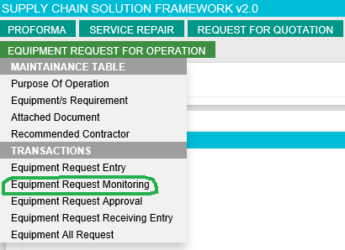

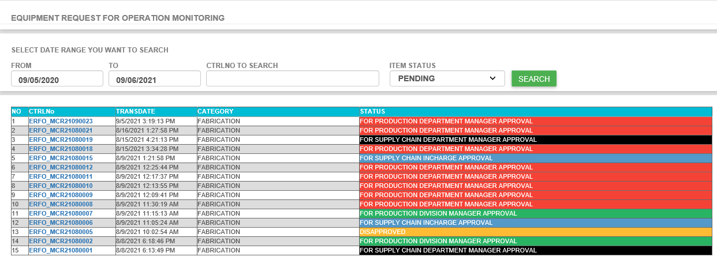

* **4.1 Click CTRL No Number if you want to see the request details.**

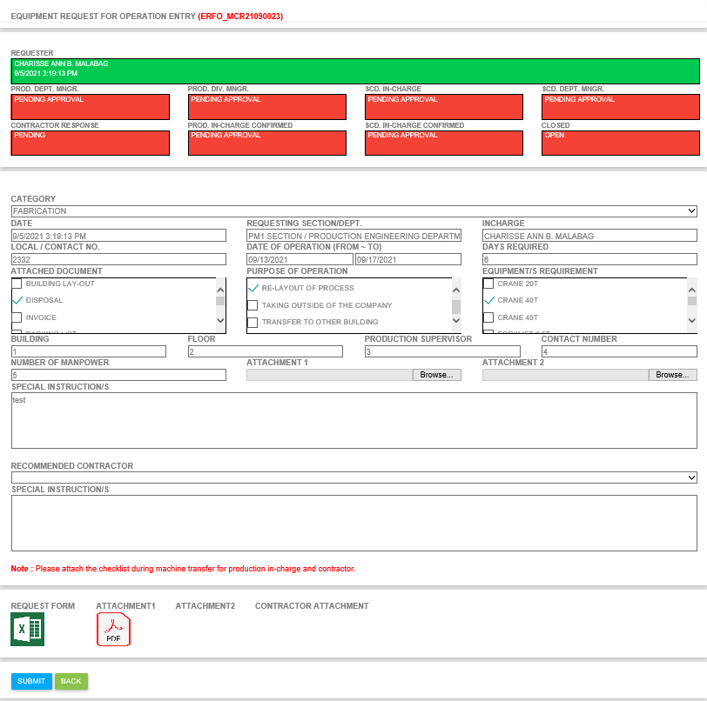

* **4.2 If you missed something on your request then you have chance to update it before your production department manager approve the request.**
* **4.3 To download the attachment, just click the icons under the attachment area.**

1. **If you want see all request the go to EQUIPMENT REQUEST FOR OPERATION > Transactions > Equipment All Request. This page is almost the same with the RFQ All Request Form for your reference.**

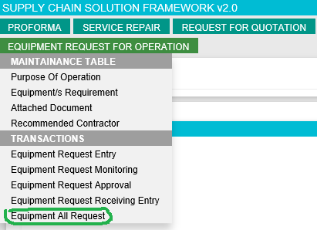

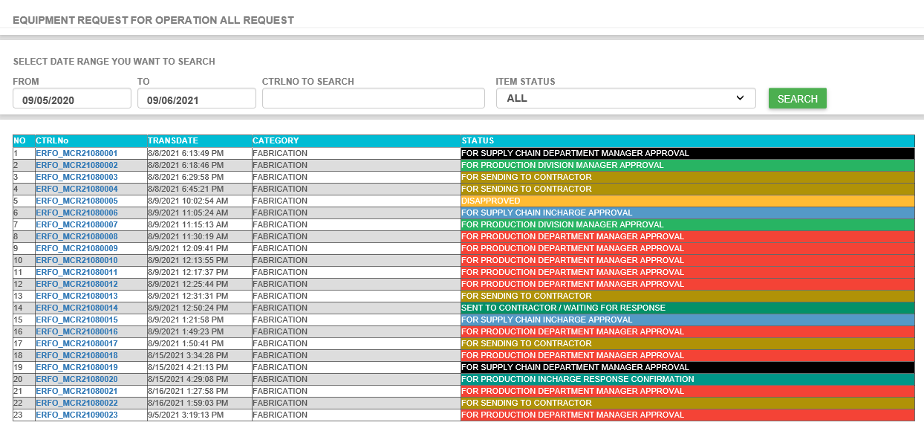

1. **If you want to approved request then go to EQUIPMENT REQUEST FOR OPERATION > Transactions > Equipment Request Approval**

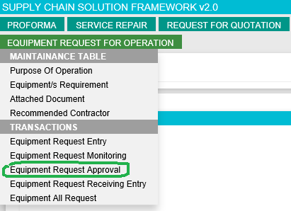

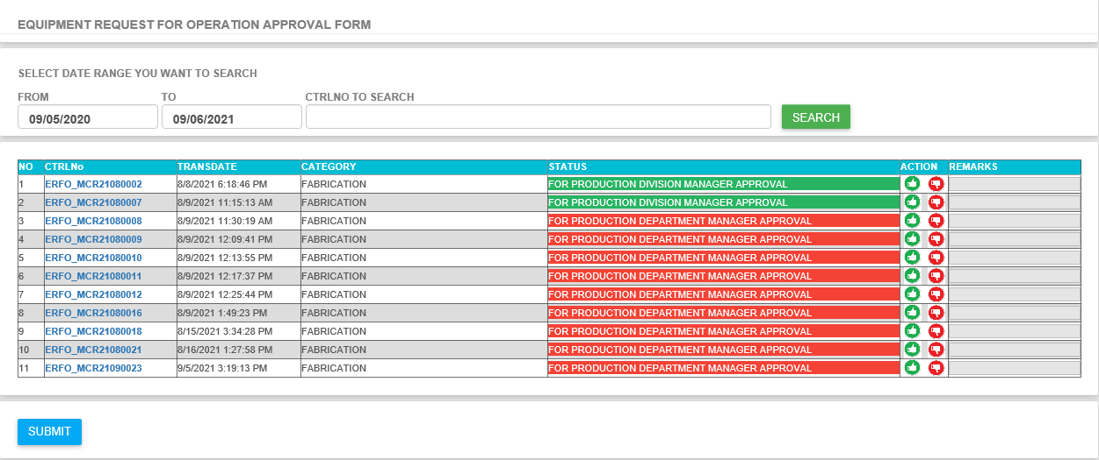

* **6.1 Click CTRLNo if you want to see the request details**
* **6.2 If request is good and ready for approval then click the green thumbs up button in ACTION column then click SUBMIT.**
* **6.3 If no error then you will be redirected to successful page.**

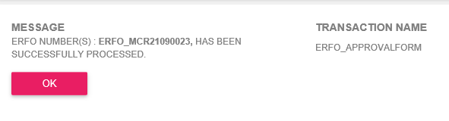

* **6.4 If you want to reject or disapproved request then click the red thumbs down button, add your disapproval remarks then click submit.**

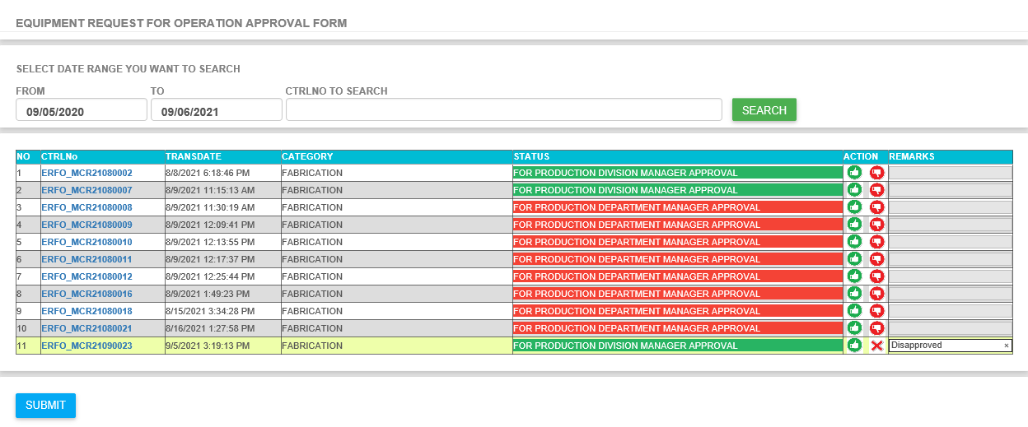

1. **If you want to see all request then go to EQUIPMENT REQUEST FOR OPERATION > Transaction > Equipment All Request**

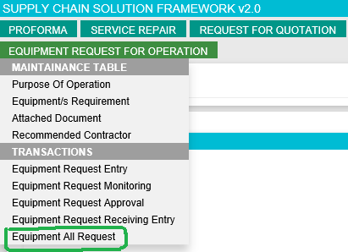

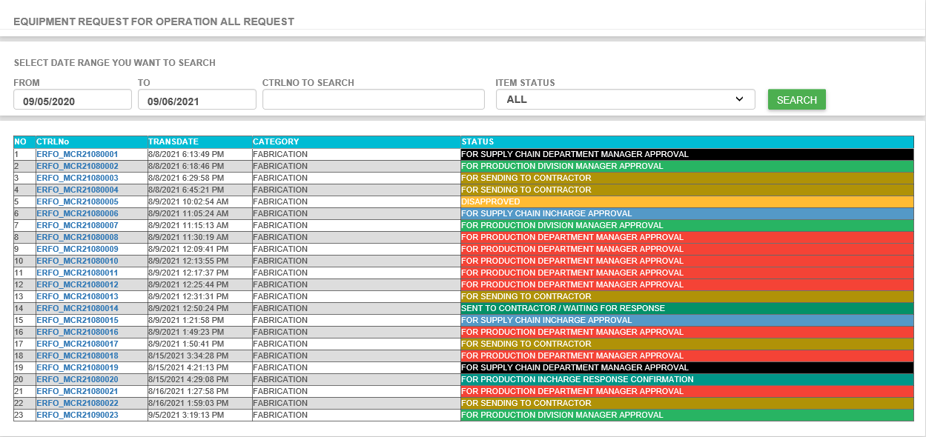

* **7. 1 Click CTRLNo if you want to see the request details**

1. **If you want to see items after the approval then go to EQUIPMENT REQUEST FOR OPERATION > Transactions > Equipment Request Receiving Entry (STRICTLY FOR *SCD Staff* Only)**

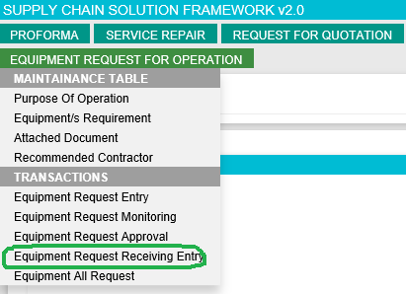

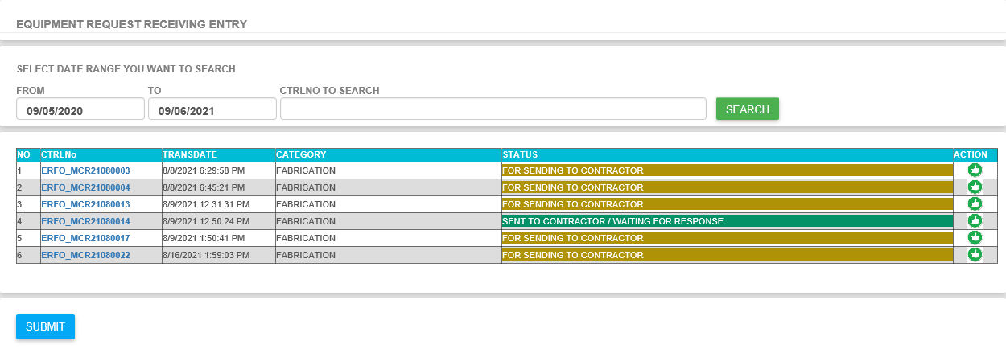

* **8.1 You can select items you want to send to Contractor. If successful then the status should be “SENT TO CONTRACTOR / WAITING FOR RESPONSE”, if not then status should be “FOR SENDING TO CONTRACTOR”.**

1. **If you want to update the Purpose of Operation Maintenance Table then go to EQUIPMENT REQUEST FOR OPERATION > Maintenance Table > Purpose of Operation (STRICTLY FOR *SCD Staff* Only)**

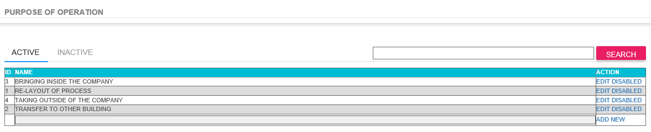

1. **If you want to update the Equipment/s Requirement Maintenance Table then go to EQUIPMENT REQUEST FOR OPERATION > Maintenance Table > Equipment/s Requirement (STRICTLY FOR *SCD Staff* Only)**

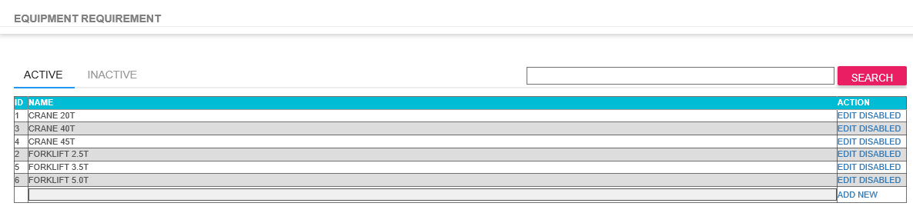

1. **If you want to update the Attached Document Maintenance Table then go to EQUIPMENT REQUEST FOR OPERATION > Maintenance Table > Attached Document (STRICTLY FOR *SCD Staff* Only)**

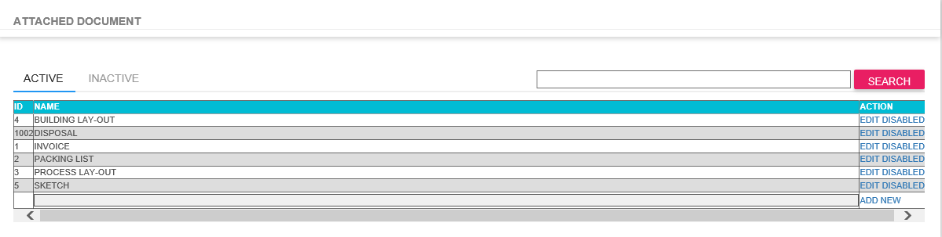

1. **If you want to update the Recommended Contractor Maintenance Table then go to EQUIPMENT REQUEST FOR OPERATION > Maintenance Table > Recommended Contractor (STRICTLY FOR *SCD Staff* Only)**

